**Day 1 & 2 Simplified**

Hello there! Since you weren’t here for the 1st and 2nd days, I’ve made a list of the basic HTML and CSS code that we used. Please familiarize yourself with the terms that are listed below. If you want a visual representation of what the code looks like, there will be screenshots at the bottom. - Lucas

### Day 1

* Tools to use
  + Repl.it - a website based code editor that allows you to write code without having to download anything
  + [How to make a Repl.it project](https://docs.replit.com/archive/quick-start#creating-a-new-python-3-repl)
    - Instead of **Python**, we are using **HTML, CSS, and JS**
* Basics of HTML
  + **Tags < >**
    - When writing HTML, we use angle brackets to define the type of element we want to create
  + **<!DOCTYPE html>**
    - a.k.a. Document Type Definition
    - Always at the top of the page (like the very top)
    - Defines the type of HTML being used
    - There are 5 different types of HTML versions. The one we are using is HTML5, the most recent version
  + **<html> </html>**
    - Defines that we are using HTML and not any other web-based language
    - Everything we write must go in between these tags
  + **<head> </head>**
    - This is the head, or brain, of the document. Just like a human body, the head stores all the information such as your name, the things you like or dislike, and other objects like your age, the school you attend, and where you live.
    - **<title> </title>**
      * Found in the head, it is what that website page is called. Just like how you have a name, so does this specific page.
    - **<meta charset=”utf-8”>**
      * Also found in the head section, this charset lets us use almost any keyboard key that we want. Some computers may not take specific keys so it’s important to add an object that allows us to use almost any keyboard key to avoid any confusion
  + **<body> </body>**
    - Just like your body which has your torso and arms (hopefully), the website’s body also has content.
    - **Headings**
      * Goes from heading 1 to 6 and defined by <h1>, <h2>, <h3>, <h4>, <h5>, <h6>, these headings are used in various ways to make content stand out in a website. For example, using a <h1> will make whatever text that is stand out the most as it is the largest
    - **<p> </p>**
      * Paragraph elements contain text that describes what’s being shown on the website. Other elements such as images can be contained within the paragraphs
    - **<i> </i>**
      * Italic element
      * Can be placed in any text element such as the headings or paragraphs
    - **<b> </b>**
      * Bold element
      * Can be placed in any text element such as the headings or paragraphs
    - **Lists**
      * Unordered list defined by <ul> </ul>
      * Ordered list defined by <ol> </ol>
      * Within these different types of lists, we use <li> </li> to insert a bullet point
    - **Anchor elements**
      * Shown by using <a> and ending with </a>
      * We use anchor elements as hyperlinks
        + Example: <a href=”google.ca”>
        + When I click on the link on my HTML page, it will take me to the website that I have linked it to
      * You can also use anchor elements to link to different parts of your website
    - **Images**
      * To enhance your website, we may want to add images. Visual aids are really helpful to someone who may be viewing your website.
      * <img src=”cat.jpg” alt=”cat” width=”100” height=”100”>
        + **Src**: where the image is located in our files
        + **Alt**: the text associated with the image. Sometimes the image might not load or a person with visual disabilities may have problems with looking at the image so adding extra (BUT SHORT) text that goes with the image helps
        + **Width**: how wide the image is
        + **Height**: how tall the image is
      * Also, images should be found within your Repl.it files. See this link to figure out how to upload a file: [How to upload files on Repl.it](https://docs.replit.com/getting-started/creating-files)
      * 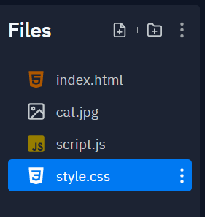
    - **Tables**
      * Start off with creating a <table> </table>
      * Within each table, there are table rows <tr> </tr>
      * Within table rows are <td> </td>
        + “Table data”
      * Why would we want to use tables?
        + Maybe to organize any data we have such as:

A schedule

Weather

Finances

### Day 2

**Cascading Style Sheets**

* Also known as CSS, they help make our websites look nice and pretty by changing colours, adding fonts, etc.
* Four types of ways to input CSS
  + Inline styles
    - Directly edit HTML tags that change the style of an object
    - E.g. <p color=”red”>This paragraph is now red</p>
  + Embedded styles
    - Found in the “head” section
    - Written in between <style> </style>
  + External styles (the ones we will be focusing on)
    - Create a new file that ends with .css
    - E.g. word.css, styles.css, etc.
  + Imported styles (we will not focus on this)

**How to use CSS**

* Within an embedded or external style, we want two things
  + The tag (p, body, main, etc.) AND brackets ({ })
  + E.g. body { }

Unlike HTML which has a rigid outline of what we may want to make, CSS is more flexible in terms of creativity for your website. Because of this, CSS can be much trickier especially the more in-depth you get in web development. Remember:

**HTML is for content, CSS is for styling**

* Color: changes the color of the text
* Background-color: changes the background color of the tag/object
* Font-size: changes font size of a tag
* Font-style: can change text style (italics, bold, etc.)
* Font-family
* Text decoration

Let’s create a styling:

Body { color: yellow; }

* Body is the **selector**
* Color is the **property**
* Yellow is the **value**
* Remember to add semicolons after the value!!!

**Classes and IDs**

* Imagine a school. You have the following:
  + Class(es)
  + id(s)
  + What's the difference????????
    - Answer: Classes are for EVERYONE and ids are for a single element
  + Class
    - Denoted by .class
    - Can be used as many times as we want as long as we specify what element uses that tag
    - E.g. <h1 class=”top”> </h1> <p class=”top”> </p>
    - .top { font-size: 200%; color: green; }
  + Ids
    - Denoted by #id
    - Unlike classes, they can only be used for one element
    - E.g. <h2 id=”bottom”> </h2>
    - #bottom { background-color: blue; font-style: italic; }

### Screenshots

**HTML**

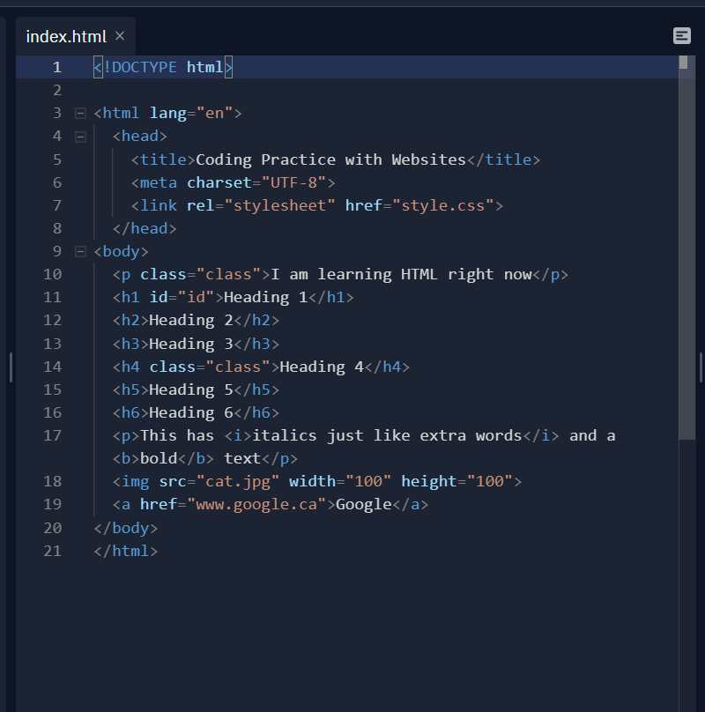

**HTML Output**

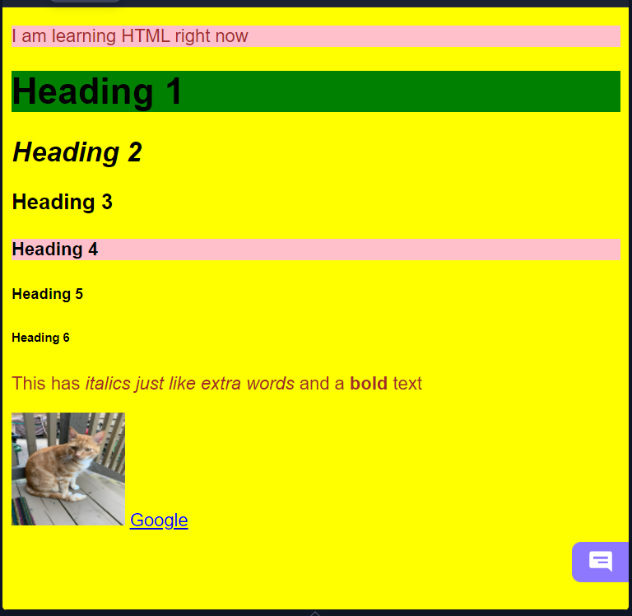

**CSS**

